|  |  |
| --- | --- |
| \\VFILERDPI\DPI-Home\OBRIENR2\My Documents\Downloads\PP logo.jpg |  |
| **COUNCIL ASSESSMENT REPORT**  HUNTER AND CENTRAL COAST REGIONAL PLANNING PANEL | |

|  |  |
| --- | --- |
| PANEL REFERENCE & DA NUMBER | PPSHCC-140 – DA 2022/95 |
| PROPOSAL | Demolition of existing Grandstand and construction of new Grandstand, amenities and function room |
| ADDRESS | Olympic Park, 3 Wilkinson Ave Muswellbrook (Lot 7010 DP 93327) |
| APPLICANT | GHD P/L |
| OWNER | Muswellbrook Shire Council |
| DA LODGEMENT DATE | 3 August 2022 |
| APPLICATION TYPE | Development Application  (Not Integrated Development) |
| REGIONALLY SIGNIFICANT CRITERIA | Clause 2.19(1) of the SEPP, the development satisfies the criteria in Clause 3 of Schedule 6 of the SEPP as the proposal is Council related development over $5 million |
| Project Cost | $8,596,000.00 (excluding GST) |
| CLAUSE 4.6 REQUESTS | NA |
| KEY SEPP/LEP | * *State Environmental Planning Policy (Resilience and Hazards) 2021;* * *State Environmental Planning Policy (Planning Systems) 2021;* * *State Environmental Planning Policy (Biodiversity and Conservation) 2021;* * *State Environmental Planning Policy (Transport and Infrastructure) 2021* * *Muswellbrook Local Environmental Plan 2009* |
| TOTAL & UNIQUE SUBMISSIONS KEY ISSUES IN SUBMISSIONS | Total number of unique submissions received Notification Period: **One (1)** |
| DOCUMENTS SUBMITTED FOR CONSIDERATION | Documents submitted as attachments to this report include:   * Attachment A: Plans Titled Muswellbrook Shire Council Olympic Park Grandstand Amenities Architectural - 12529663 * Attachment B: Recommended Conditions of Consent * Attachment C: ARTC –General Terms of Approval * Attachment D: Olympic Park Grandstand Noise Impact Assessment * Attachment E: Applicant Response to submissions   Documents available to the Panel separate to the report attachments include:   * The Statement of Environmental Effect, appendices and additional information responses. * Olympic Park Master Plan * Olympic Park Plan of Management * Olympic Park Grandstand Hazardous Building Materials Assessment * Olympic Park Grandstand Traffic Assessment * Native Title Manager Advice - Final Draft Plan of Management for Olympic Park * Social Impact Assessment - Olympic Park Event Precinct Development * Public Submissions. |
| SPECIAL INFRASTRUCTURE CONTRIBUTIONS (S7.24) | Not Applicable |
| RECOMMENDATION | Approval subject to conditions |
| DRAFT CONDITIONS TO APPLICANT | Yes |
| SCHEDULED MEETING DATE | 14 February 2024 |
| PLAN VERSION | 22 November 2022 Version No 3 |
| PREPARED BY | Sharon Pope – Director Environment and Planning |
| DATE OF REPORT | 6 February 2024 |

**EXECUTIVE SUMMARY**

The proposed development involves the demolition of an existing Grandstand in Olympic Park and the construction of a larger Grandstand and new player amenities, a club house, and spaces for supporting activities. Olympic Park is a sporting precinct comprising rugby league fields and grandstand, tennis courts, the Ron King Velodrome, the Muswellbrook Aquatic Centre, and two bowling greens.

The proposed development has been referred to the Hunter and Central Coast Regional Planning Panel for determination pursuant to Clause 3 of Schedule 6 of *State Environmental Planning Policy (Planning Systems) 2021* as the proposal is Council related development over $5 million.

The proposed development was publicly notified in accordance with Council’s Community Participation Plan on one occasion. One (1) unique submission was received.

The submissions received has resulted in a change to proposed building colours.

Council Officers have completed an assessment of the proposed development against the relevant heads of consideration of Section 4.15 of the *Environmental Planning Assessment Act 1979*. This assessment has concluded that the development application be approved subject to conditions of consent.

Key findings of the Section 4.15 Assessment include:

* The proposed development would be in accordance with the relevant provisions of the Muswellbrook LEP 2009. Council Officers are satisfied that the relevant land use is characterised as an ‘Recreation Facility (major)’ and ‘Function Centre’. Development for the purpose of Recreation Facility (major) and Function Centre is permissible with consent within the RE1 Public Recreation zone under the Muswellbrook LEP 2009.
* The proposed development would be compatible with the requirements of relevant State Environmental Planning Policies (SEPPs), including, SEPP (Resilience and Hazards) 2021, & SEPP (xx) 2021.
* The proposed development is generally in accordance with the requirements of the Muswellbrook Development Control Plan 2009 (DCP) and conditions of consent have been recommended to ensure the development is carried out in accordance with certain DCP provisions.
* ARTC provided General Terms of Approval to the proposed development.
* The proposed upgrade to the Grandstand and amenities is identified in the adopted Olympic Park Plan of Management.
* While the site of the proposed development:
* would be impacted by floodwaters greater than the 1% AEP event, and
* access to the development site would be restricted during periods of heavy rainfall and flooding, particularly the 1% AEP event.

any scheduled events that would utilise the Grandstand would be cancelled during periods of prolonged wet weather to avoid damage to the surface of adjoining playing fields.

* The Traffic Impact Assessment indicates that:
* In the 2032 horizon year, the intersections of interest are expected to operate with a good LoS for the “build” and “no-build” scenarios.
* The trips associated with the new grandstand are expected to have a minor impact on the operation of the road network.
* The Use of the Grandstand for Major Events may create noise impacts for some nearby residents. As major events are likely to be infrequent, these impacts will be irregular. To provide certainty for residents it is proposed to cap the number of major events to a maximum of six (6) in any calendar year.

**THE SITE AND LOCALITY**

* 1. **The Site**

The site is located within the Muswellbrook Olympic Park precinct on part Lot 7010 DP 93327, 3 Wilkinson Avenue, Muswellbrook, NSW. The subject site is bound by Haydon Street to the west, the New England Highway to the south, Bell Street to the east, and Australian Rail Track Corporation (ARTC) railway corridor to the north. Lot 7010 DP 93327 is Crown parcel that is currently managed by Council.

The current sporting field areas were originally the site of the Muswellbrook Showground and have been used for organised field sports since the late 1800’s. The Showground moved from the reserve in 1955. Amenities were constructed, with the current integrated grandstand and amenities building developed in 1982. The fields are used predominantly for Rugby League in the winter and Touch Football in the summer.

Along with the Muswellbrook golf course, the Olympic Park precinct forms the northern end of an almost 3.2 km long green space corridor running primarily east of the New England Highway from Wilkinson Avenue in the north and along the length of Muscle Creek to Bimbadeen Drive in the south. The site is located directly adjacent to areas zoned E2 Commercial Centre to the north along Market Street and Victoria Street, E3 Productivity Support to the west along Maitland Street and Sydney Street, and R1 General Residential also along Maitland Street, Wilder Street, Gyarran Street, Clifford Street, Victoria Street and Bell Street.

The site is strategically located between Singleton and Scone, approximately a 40-minute drive from Singleton and 25-minute drive from Scone.

The image 1 below identifies the subject site.

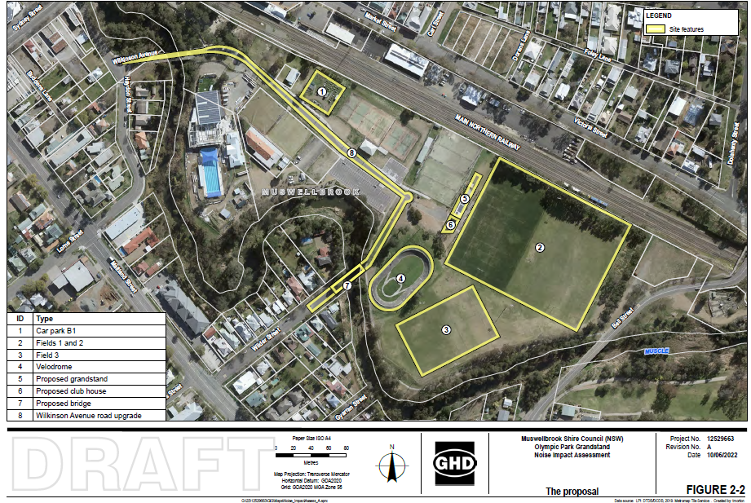

Image 1. Site of the proposed Grandstand in relation to other uses at Olympic park

* 1. **The Olympic Park Sporting Precinct.**

The proposed new Grandstand and amenities are identified within the Olympic Park Master Plan and the Olympic Park Plan of Management.

Olympic Park is a sporting precinct comprising rugby league fields and grandstand, tennis courts, the Ron King Velodrome, the Muswellbrook Aquatic Centre, and two bowling greens.

The existing grandstand is located on the eastern boundary of the tennis courts and western boundary of the existing playing field (Olympic Park). The new grandstand will retain the orientation of the existing grandstand, which faces south-east to the existing playing field.

The site of the Proposal is generally flat. The adjoining land consists of maintained open grassland accommodating two existing football fields directly east, a junior football field directly southeast, and a velodrome directly south of the site. A number of semi mature trees and shrubs are scattered throughout the vicinity of the site.

1. **THE PROPOSAL AND BACKGROUND** 
   1. **The Proposal**

2.1.1 General overview

The project involves demolishing an existing Grandstand that has begun to show signs of concrete cancer and does not meet contemporary standards for male and female change rooms, all abilities access, or food preparation areas. The existing grandstand is a brick and steel structure of two-storey construction. The existing grandstand has capacity for approximately 444 spectators and comprises bathroom facilities, changerooms, referee’s room and a kiosk located on the lower level. The grandstand seating area is located above on the second storey. Shipping containers provide additional storage.



Image 2. Existing Grandstand

When the application was originally submitted, the construction of the new Grandstand and Amenities was proposed to be in two stages. Amended plans provided in November 2022 changed this to construction occurring in a single stage.

The proposal aims to cater for local sporting requirements but is also designed to hold high performance sporting events either at youth or senior level. There is also the potential for the facility to be used for non-sporting uses such as business functions and entertainment.

The new facility involves a NRL Regional Level Standard grandstand and associated facilities. These facilities will be distributed over three (3) levels. Provided below is a summary of all the facilities located on each level of the proposed facility and The Proposal footprint is shown Figure 1.

***Table 1 Facility design details***

|  |  |
| --- | --- |
| Level | Detail |
|  |  |
| Ground level | – Male and female change room with WC and showers x 2  – WC x 2  – Massage rooms x 4  – Bar & canteen/kiosk  – Lobby  – Admin room  – First aid room  – Changing places room Acc  – Strength & conditioning room  – Referee room  – Storeroom x 3  – Dry servery  – Time keeper room  – Referee toilets |
| Level 1 | - Terrace  – Function room  – Club/social/community space  – Kitchen  – Bar  – Male and female WC  – Store rooms x 2  – Comms room |
| Level 2 | – Coaches box x 2  – Media room |

The current grandstand has a capacity of 444 seats, while the proposed grandstand will provide (approximately) 870 seats, an increase of 426 seats.

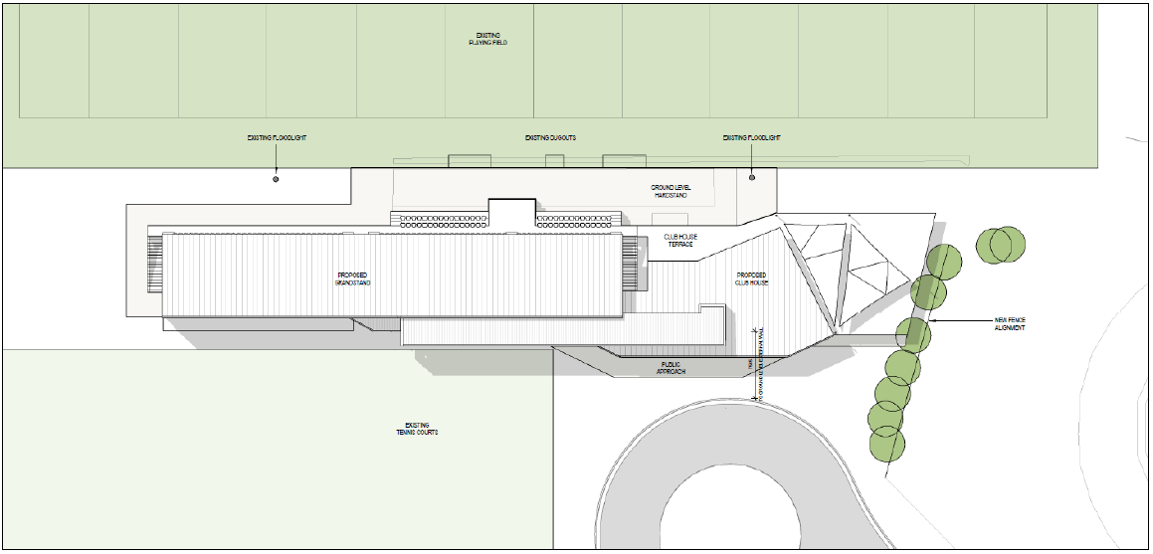

Figure 1 – Proposal location and footprint.

The Applicant has provided a number of example Event Management Plans and Traffic Management Plans for Events. These cover matters such as crowd management, noise minimisation, off-site parking and transport, and waste management.

2.1.2 Operational Information

The proposed hours of operation associated with the football fields and grandstand are set out in Table 2.

|  |  |  |
| --- | --- | --- |
| Facility | Time of use | Description of use |
|  |  |  |
| Football fields 1,2 and 3.  Grandstand | 7 am to 10 pm | * Major regional events and competitions * Typical local sporting events * Training * Small community events |
| Main building  Carpark | 7 am to 12 pm | * Sporting participants and visitors to the main building and playing fields * carpark for Entertainment events * Venue for small community events |

Table 2. Proposed hours of operation

2.1.3 Policy Context

**Olympic Park Plan of Management (PoM)**

The Olympic Park Plan of Management was adopted in December 2023.

A Plan of Management (PoM) is a document which provides a clear set of guidelines for the short- and long-term management of a parcel of ‘community land’ owned and managed by Council or Crown land under Council’s care, control and management.

A Plan of Management outlines how a park or reserve will be used and improved and managed in the future. It identifies Council’s goals and objectives for the land and establishes the overall direction for its planning, resource management and maintenance. The Plan of Management can be accompanied by a landscape masterplan and assists Council to set priorities when preparing Works Programs and related budgets.

The Plan of Management applies to the group of reserves including Fitzgerald Park and Olympic Park and part of the Muswellbrook Golf Course. The street address of the Precinct includes Wilkinson Avenue (Fitzgerald Park and Olympic Park) and Bell and Maitland Streets (Muswellbrook Golf Course).

The Plan of Management expressly authorises development of new buildings and structures, and redevelopment/ refurbishment of buildings and structures, which support the desired use of Olympic Park Precinct.

Such buildings and structures are to be consistent with:

* The adopted 2018 Olympic Park Master Plan and any subsequent detailed design plans.
* The Muswellbrook LEP 2009 and any applicable Development Control Plans.
* The Building Code of Australia.
* Access to new facilities on the site and any refurbishment of those structures will be provided according to Design for Access and Mobility Standards.
* Access and seating requirements for people with disabilities and compliance with Disability Discrimination Act; and
* Sustainable development and integrate sustainability in terms of energy use, life cycle costs, source material impacts, and Water Sensitive Urban Design (WSUD).

The impact of traffic and parking associated with organised sport or community events on neighbouring residents and businesses will be managed by preparing a Traffic and Parking Plan on a case-by-case basis for consideration by Council when granting consent for such activities/ events.

The Development Application is on land within an area designated as Sportsground and Park in the PoM.

The core objectives for management of Community Land Categorised as a sportsground are:

1. To encourage, promote and facilitate recreational pursuits in the community involving organised and informal sporting activities and games; and
2. To provide casual recreational, cultural, social and educational pastimes and activities

Table 3. Management Factor Objectives for the Organised Sport relevant to this development application are:

|  |  |
| --- | --- |
| **Objective** | **Means/Strategies** |
|  |  |
| To manage and improve Olympic Park Precinct as a hub for organised sports | * Maintain and improve sports field facilities where possible * Maintain and improve grandstand facilities * Provide expanded and improved change rooms and amenities to cater for diverse range of users * Provide multipurpose function space as part of new building works for use by sports groups and general community |
| To provide for effective universal access | * Integrate accessibility and accessible use provisions to sports facilities as applicable |
| To effectively control sale of alcohol on sportsground areas | * Prohibit consumption of alcohol within sportsgrounds where indicated by ordinance regulations * Require site users to obtain Council consent and a Liquor licence if sale of alcohol during events is proposed, in compliance with Liquor Act 2007 and Liquor Regulations 2018. Evidence of current Liquor licence supplied to Council annually or as required for issue of permits |
| To provide for effective drainage of facilities | * Provide water quality management as part of WSUD strategies to roads and carparks * Investigate water harvesting as part of WSUD strategies to roads, carparks and tennis courts |
|  |  |

Permitted development and use for areas categorised as Sportsground or Park include:

* Organised and unstructured recreation and sporting activities
* Casual or informal recreation
* Meetings, community events and gatherings (including for social, recreational, educational or cultural purposes)
* Group recreational use, such as picnics and private celebrations
* Festivals, parades, markets, fairs, exhibitions and similar events and gatherings
* Concerts, including all musical genres
* Performances (including film and stage)
* Exhibitions
* Fairs and parades
* Leisure or training classes
* Entertainment facilities
* Filming and photographic projects
* Amplified sound
* Commercial uses associated with sports facilities
* Low-intensity commercial activities (for example recreational equipment hire)
* Busking
* Public address (speeches)

**Olympic Park Master Plan**

The Olympic Park Master Plan was adopted by MSC in 2018.The intent of the Master Plan was to develop a strategic approach to the redevelopment of Olympic Park.

The Master Plan notes that:

* The existing grandstand is in need of an upgrade with regard to accessibility and visual amenity
* Additional change rooms are needed to accommodate women’s and men’s games overlapping
* Site drainage [of the playing fields] needs to be addressed
* Secure fence is proposed to lock the grounds after hours or when not in use. This will stop people crossing the fields

The Master Plan identifies a range of improvements and breaks these into stages to be completed as funding becomes available. The improvements relevant to this development application are:

* Upgrade of Wilkinson Avenue
* Construction of a new bridge over Muscle Creek to provide a new egress from the precinct from Wilder Street.
* Carparking areas which provide a total of 100 spaces. This includes an allowance for future carparking expansions in Stage 2
* Relocation of the heritage gates to the football precinct forecourt at the eastern end of Wilkinson Avenue
* Field improvement and drainage to Fields 1 and 2
* Irrigation and upgrades to Field 3. Field 3 to be used for touch football and training. Field 3 proposed as a public kick about space
* 1800mm high palisade fence to enclose Fields 1 and 2. The Palisade fence to be black to allow for visual permeability
* Provision of two new parking areas and the completion of the tennis facility parking areas. This provides an additional 116 parking spaces for a total of 216 spaces. This does not include existing parking for the pool and bowling club facilities
* New Grandstand

- 1000 seats

- 2 x change rooms and associated facilities

- storage

- Public amenities

- Kiosk and Bar

- Administration and ticket office

Bus Parking

Two locations are proposed for bus parking. The first is on the northern side of Wilkinson Avenue opposite Park Tennis. The second is on the eastern side of Wilkinson Avenue opposite the Velodrome. Together, these locations provide space for approximately 5 buses.

During major events the egress of the buses will be via Wilder Street and left out onto the New England Highway.

* 1. **Site Information**

2.2.1 Servicing

The existing grandstand structure is currently connected to Council’s reticulated water and sewer infrastructure and has the capacity to support an upgrade to the grandstand structure to accommodate an increase in patrons and spectators.

Electricity and telecommunications are currently available and serve the existing grandstand. The current infrastructure has sufficient capacity to service the Proposal.

2.2.2 Stormwater

The existing stormwater and drainage network for the current Grandstand includes stormwater pipes, pits and graded surface inlets and run adjacent to the proposed facility along the eastern, western, and southern perimeters. The network includes an existing headwall and channel outlet which is assumed to drain out to Muscle Creek.

2.2.3 Accessibility

There is a single access to the Olympic Park precinct from Sydney Street via Haydon Street then connecting onto Wilkinson Avenue. Vehicle access to the site will continue to be via Wilkinson Avenue. A secondary access point from Wilder Street is available for major events.

Wilkinson Avenue is a local road that provides access to the existing grandstand at the subject site. Access to Wilkinson Avenue is via Haydon Street at its western end. The road terminates at the entrance to the Olympic Park precinct. Key features of Wilkinson Avenue are summarised in Table 3

Table 4 Description of Wilkinson Ave

|  |  |
| --- | --- |
| **Feature** | **Description** |
| Carriageway | Sealed carriageway with one lane in each direction, with a travel width of approximately 3.5 metres per lane. No lane markings are provided. Kerb and gutter are provided along the length of the carriageway. |
| Parking | On-street parking permitted on both sides of the road. |
| Speed Limit | 50km/hr |
| Pedestrian Facilities | Footpath provided on the northern side of the road. |
| Bicycle Facilities | None provided |
| Public Transport | No route enters the site. Closest stops are in Bell Street and Maitland Street. |

To identify the traffic volumes in the proximity of the subject site, GHD engaged Trans Traffic Survey Pty Ltd to undertake turning movement counts at the intersections of Haydon Street/Bridge Street, Haydon Street/Wilkinson Avenue and Haydon Street/New England Highway/Lorne Street (refer to Figure 2.13) on Saturday, 18 June 2022 between 11:00 am – 2:00 pm.

The date and timing of the surveys were discussed and agreed with the Client and captured vehicle activity associated with a rugby tournament.

The peak hour of activity was identified as 11:00 am – 12:00 pm.

The data in Table 5 indicates that the intersections currently operate with an acceptable LoS.

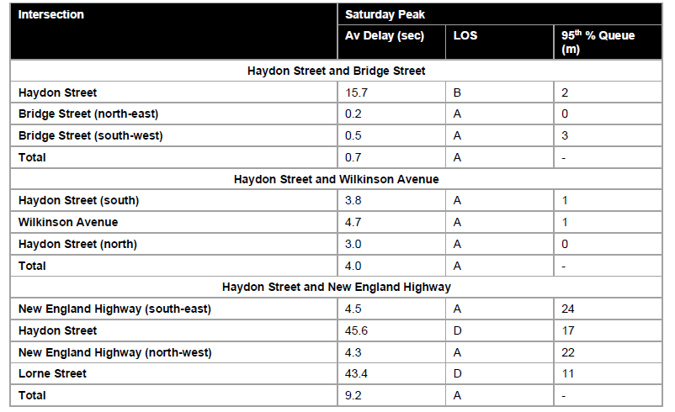

Table 5- Current intersection performance

The trip generation for the proposed new Olympic Park Grandstand (Stage 2) has been undertaken on a first principals basis accounting for the expected increase in capacity.

The current grandstand has a capacity of 444 seats, while the proposed grandstand will provide (approximately) 870 seats, an increase of 426 seats.

It is expected that there will be multiple people per vehicle associated with the operation of the proposed grandstand, i.e. a family watching a child play sport. For the purposes of analysis, The Traffic Impact Assessment assumed that there will be an average car occupancy of 1.5 people for vehicle trips associated with the grandstand.

Additionally, not all vehicles will access/egress the grandstand in a single hour. The outputs of the traffic surveys (from 11:00 am – 2:00 pm) for Wilkinson Avenue indicate that approximately 40 percent of the overall activity occurred in a single peak hour.

Therefore, the proposed grandstand is expected to generate 114 vehicle trips. To be conservative, the Traffic Impact Assessment has assumed that 114 vehicle trips will access and egress the grandstand in a single hour.

The 2032 SIDRA outputs for the “build” and “non-build” scenarios are displayed in Table 6.

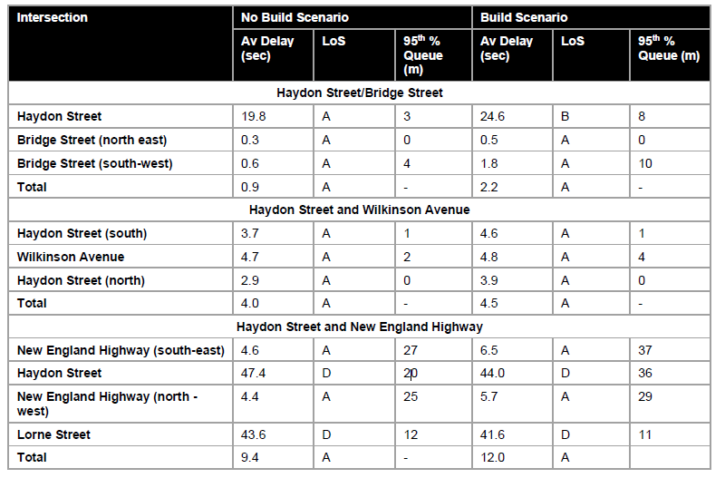

Table 6 – 2032 Intersection performance

The results in Table 4.1 indicates that:

* In the 2032 horizon year, the intersections of interest are expected to operate with a good LoS for the “build” and “no-build” scenarios.
* The trips associated with the new grandstand are expected to have a minor impact on the operation of the road network.

The internal road and parking area adjoining the existing Grandstand at Olympic Park have been reconstructed recently. Four (4) parking spaces for people with disabilities has been provided in a nearby parking area. The path of travel between the parking area and the Proposal is a relatively flat grade. An image of the parking area is provided below.

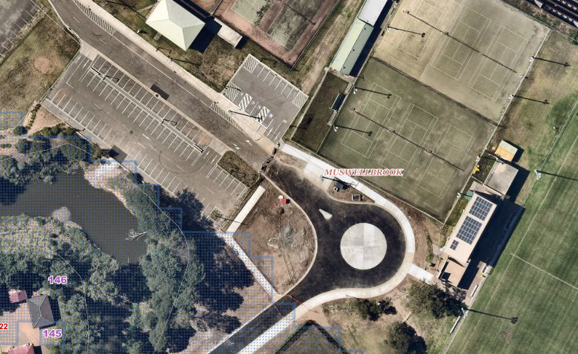

Image 3. Car parking, vehicle and pedestrian access to subject site.

Olympic Park currently contains a total of 172 formalised car parking spaces, with additional overflow parking available. These spaces are located within walking distance to the proposed facility, two of which are located approximately 60 metres from the western boundary of the site. The car parking facilities are associated with the sports fields and leisure facilities currently located in the precinct, including Muswellbrook Aquatic and Fitness Centre.

The site is currently served by public transport services within 1 km walk from Muswellbrook Station, which is served by NSW TrainLink Hunter Line services travelling between Newcastle and Scone. The train station is also served by NSW TrainLink Xplorer services from Sydney to Armidale.

* 1. **Site History**

Numerous development consents have been issued for various facilities and improvements in the Olympic Park Precinct. A search of Council’s record system identifies recent development applications for the subject site:

DA 2019-11 – Upgrades, alterations and additions to the Muswellbrook Aquatic Centre.

DA 2018-111 – Alterations to the Muswellbrook Amateur Theatrical Society building.

DA 2007-97 – Change of use of a bowling club to a community centre.

1. **STATUTORY CONSIDERATIONS** 
   1. **Crown Land Management Act 2016**

The CLM Act allows the governance of Crown reserves across NSW and in recognition of the role that local councils have in this governance, the CLM Act enables local councils to manage Crown land under the *Local Government Act 1993.*

The proposal is located within Lot 7010 of DP93327 which is a Crown Reserve (R570025) reserved for public recreation purposes. Under Division 2.4 of this Act, the use of dedicated of reserved Crown land may only be used for the following purposes:

1. The purposes for which its dedicated or reserved
2. Any purpose incidental or ancillary to a purpose for which it is dedicated or reserved
3. Any other purpose authorised by or under this Act or another act

The proposal is considered consistent with this provision and the purposes of the Crown reserve for public recreation by providing an ancillary structure and associated amenities at the Muswellbrook Olympic Park Precinct to service the public and community.

* 1. **Native Title Act 1993**

The NT Act 1993 may affect use of Crown land, particularly development of the land and granting of tenures.

In particular, the CLM Act makes it mandatory for Council to engage or employ a Native Title Manager. This role provides advice to Council as to how the Council’s dealings and activities on Crown land may be valid or not valid under the NT Act.

There are two active Native Title Claims in the Muswellbrook Shire Council LGA that do not include the Olympic Park reserves (D570025 and R1010588). There has not been any Native Title Determinations, Indigenous Land Use Agreements, Native Title Future Act Applications and Determinations, or Native Title Certificates issued for the Olympic Park reserves (D570025 and R1010588).

Advice provided to Council by an accredited Native Title Manager as part of preparation of the Plan of Management for Olympic Park is that:

* The majority of the Olympic Park reserves (D570025 and R1010588) have been subject to Previous Exclusive Possession Acts (PEPAs), where alienation through previous freehold ownership, public works and community lease has occurred that is inconsistent with the continued existence of Native Title.
* Council may have confidence that in the event of any Native Title claim over the affected land in the Olympic Park reserves (D570025 and R1010588), that for the purposes of the NT Act (Cth)and the NT Act (NSW), the acts that affect the parts of the Olympic Park Reserve may be regarded as having the effect of having extinguished native title rights over the relevant land areas.
* The adoption of the Plan of Management by Council, in good faith, and with proposed uses, developments and tenures that are in accordance with the dedication, and the purposes of the Crown reserves is a future act that meets the requirements of validation under the NT Act (Cth) Subdivision J, Section 24JA, Section (1) (a-e).

**Heritage Act 1977**

The site includes a mapped heritage item - general under Muswellbrook LEP 2009 for the item ‘Fitzgerald/Olympic Park Gates’ (item 125). The proposal would not impact on any heritage items listed on the local or state heritage register and is not likely to disturb a relic. As a result, approval under the Heritage Act is not required.

The Proposal was referred to Council’s Heritage Advisor for comment and his response is provided under the referral section below.

* 1. **Biodiversity Conservation Act 2016**

The subject site is not identified on DPIE’s Biodiversity Values Map and Threshold Tool as having any ‘biodiversity values’ and therefore doesn’t trigger provisions of the BC Act. The proposal would not:

* Impact on any area of outstanding biodiversity value (as declared by the Minister)
* Exceed the Biodiversity Offset Scheme threshold (as no native vegetation would be removed)
* Is not mapped in the biodiversity values map and is not located within close proximity to a biodiversity area
* Would not have a significant impact on threatened species or endangered ecological communities

Given the above, no further consideration of biodiversity or ecological issues under the Act is required.

* 1. **Environmental Planning and Assessment Act 1979**

Section 4.46 of the EP&A Act, outlines that development that requires both development consent and one or more of the listed approvals is ‘integrated development’. The proposal does not require any of the listed approvals and therefore does not constitute integrated development under the EP&A Act.

Section 4.15(1) of the *Environmental Planning and Assessment Act 1979* (‘EP&A Act’) outlines matters of consideration when assessing the development application and include the following:-

**Section 4.15(1)(a)(i) - Provisions of Environmental Planning Instruments**

Relevant State Environmental Planning Policies are outlined below.

1. **State Environmental Planning Policy (Sustainable Buildings) 2022**

This SEPP was published on the 29 August 2022, with the operation of some provisions delayed until 1 October 2023. As a result, the SEPP was not in force when the Development Application was lodged.

If it had been in force the following provision would have been relevant:

*3.2 Development consent for non-residential development*

*(1) In deciding whether to grant development consent to non-residential development, the consent authority must consider whether the development is designed to enable the following—*

*(a) the minimisation of waste from associated demolition and construction, including by the choice and reuse of building materials,*

*(b) a reduction in peak demand for electricity, including through the use of energy efficient technology,*

*(c) a reduction in the reliance on artificial lighting and mechanical heating and cooling through passive design,*

*(d) the generation and storage of renewable energy,*

*(e) the metering and monitoring of energy consumption,*

*(f) the minimisation of the consumption of potable water.*

*(2) Development consent must not be granted to non-residential development unless the consent authority is satisfied the embodied emissions attributable to the development have been quantified.*

While not a consideration in this assessment, the detailed design and construction phase of the development should aim to maximise sustainability of the building.

1. **State Environmental Planning Policy (Planning Systems) 2021**

*State Environmental Planning Policy (Planning Systems) 2011* applies to the proposal. Pursuant to Clause 2.19(1) of the SEPP, the proposal is a regionally significant development as it satisfies the criteria in Clause 3 of Schedule 6 of the SEPP as the proposal is Council related development over $5 million.

1. **State Environmental Planning Policy (Resilience and Hazards) 2021**

The provisions of Chapter 4 of the *State Environmental Planning Policy (Resilience and Hazards) 2021* have been considered in the assessment of the development application. Clause 4.6 of the SEPP requires consent authorities to consider whether the land is contaminated, and if the land is contaminated, it is satisfied that the land is suitable in its contaminated state (or will be suitable, after remediation) for the purpose for which the development is proposed to be carried out.

Historically, soil may have been introduced to the site for the purposes of levelling the ground. The site was used for a Showground prior to being used for playing fields and a Grandstand. A showground is not a use listed in the Contaminated Land Planning Guidelines as potentially contaminating land use.

As the proposed development does not seek to change the use of the land and does not create or intensify a residential use on the land, a soil contamination assessment was not requested to further investigate the issue further.

A Hazardous Building Materials (HBM) assessment was submitted with the application. The objective of the HBM Pre Demolition assessment was to locate, assess and document a risk assessment for all identified and suspected HBM within the building, as far as reasonably practicable, for the purpose of demolition or partial demolition.

* The HBM have been limited to:
* Asbestos containing materials (ACM)
* Suspected Lead based paint systems (LBP)
* Synthetic mineral fibres (SMF) and
* Polychlorinated biphenyls (PCBs) within light capacitors

The grandstand building/structure and surrounds assessed within this report is shown on Image 4 below.

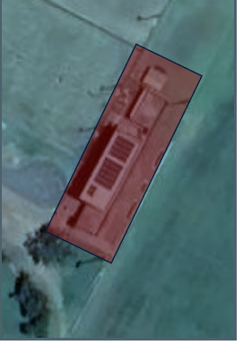

Figure 8 – Area subject to the Hazardous Building Materials assessment

Asbestos and Synthetic mineral fibres were identified. The Report recommends their removal prior to demolition of the existing Grandstand.

Conditions of consent have been recommended to address this matter.

1. **State Environmental Planning Policy (Transport and Infrastructure) 2021**

Chapter 2- s.2.10 Infrastructure, outlines the need for consultation with councils to consider the impact on council related infrastructure. Some of this occurred at a high level with the development of eth Olympic Park PoM and the Olympic Park Master Plan. The Development Application was also referred to Council’s Engineering staff for comment. These comments are provided below in the section on referrals.

Chapter 2- s.2.122 and Schedule 3 of this SEPP includes provisions related to the identification and assessment of development as ‘traffic generating development’. The criteria for identifying whether a proposed development qualifies as ‘traffic generating’ is established by Schedule 3. Under those provisions this development would not be characterised as ‘traffic generating’ development as it would generate 200 or less traffic movements per hour. The Traffic Impact Assessment provided indicated that vehicle movements would equate to a maximum of 114 traffic movements an hour in a worst case scenario.

Transport for NSW were asked if they would like a referral for comment and they advised that they did not wish to comment.

Chapter 2 – s.2.11 Heritage, requires consultation with councils if development is likely to affect the heritage significance of a heritage item or conservation area. While Olympic Park accommodates a local heritage item identified under Muswellbrook LEP (item 124 ‘Fitzgerald/ Olympic Park Gates’). The proposal will not affect the heritage significance of this local heritage item. The Application was referred to Council’s Heritage Advisor for comment. These comments are provided below in the section on referrals.

Division 15 – s.2.97 Development adjacent to rail corridors, does not apply to the Proposal the new building is approximately 40 metres south from the railway corridor. The Application was referred to ARTC for comment. These comments are provided below in the section on referrals.

1. **State Environmental Planning Policy (Biodiversity and Conservation) 2021**

This SEPP establishes provisions related to the clearing of vegetation in non-rural areas.

This SEPP establishes provisions related to the clearing of Koala Habitat. Chapter 3 of the SEPP applies to the Muswellbrook Local Government Area. In accordance with the SEPP, a consent authority is required to have regard to whether the land concerned is a potential or core koala habitat, and where land is identified as a core koala habitat a plan of management is to be prepared in relation to that habitat in accordance with provisions set out in the SEPP.

Inspection of the site and the ecological information submitted by MJD Environmental observe that the land had been previously cleared. The site is not potential or core koala habitat requiring further consideration under the provisions of the SEPP.

1. **Muswellbrook Local Environmental Plan 2009**

*Muswellbrook Local Environmental Plan 2009* (MLEP 2009) applies to the site. The aims of the LEP include

*(aa)  to protect and promote the use and development of land for arts and cultural activity, including music and other performance arts,*

*(a)  to encourage the proper management of the natural and human-made resources of Muswellbrook by protecting, enhancing or conserving—*

*(i)  productive agricultural land, and*

*(ii)  timber, minerals, soils, water and other natural resources, and*

*(iii)  areas of significance for nature conservation, and*

*(iv)  areas of high scenic or recreational value, and*

*(v)  places and buildings of archaeological or heritage significance,*

*(b)  to manage the urban areas of Muswellbrook by strengthening retail hierarchies and employment opportunities, promoting appropriate tourism development, guiding affordable urban form and providing for the protection of heritage items and precincts,*

*(c)  to promote ecologically sustainable urban and rural development,*

*(d)  to manage development in flood-prone areas by ensuring any obstruction, re-direction or pollution of flood waters will not have adverse consequences for the environment or increase the risk of endangering life or property,*

*(e)  to enhance the urban amenity and habitat for flora and fauna,*

*(f)  to protect and conserve—*

*(i)  soil stability by controlling development in accordance with land capability, and*

*(ii)  remnant native vegetation, and*

*(iii)  water resources, water quality and wetland areas, natural flow patterns and their catchments and buffer areas,*

*(g)  to provide a secure future for agriculture by expanding Muswellbrook’s economic base and minimising the loss or fragmentation of productive agricultural land,*

*(h)  to allow flexibility in the planning framework so as to encourage orderly, economic and equitable development while safeguarding the community’s interests and residential amenity, and to achieve the objectives of each zone mentioned in Part 2 of this Plan.*

The proposal is compliant with aims (aa) and (b)in view of to the following:

* The proposal would establish an occasional employment generating use at the site associated with the potential for functions and sporting events.
* The proposed development would support diversification of Muswellbrook’s economic base and potential attracts visitors to the area.
* The proposal strengthens the Muswellbrook’s position as a regional centre

Zoning

The site is located within the RE1 Public Recreation.

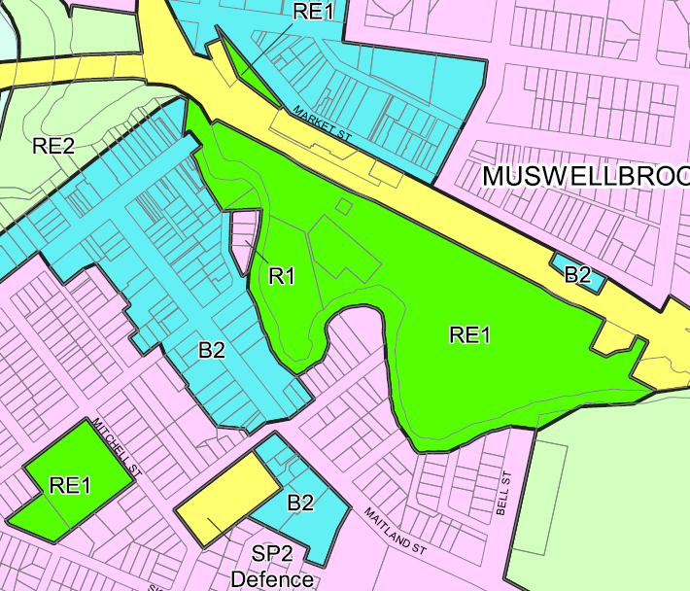

Figure 3 (MLEP 2009 Land use zoning map). Note, the legislation website maps have not been updated, the B2 zone is now E2 Commercial Centre to the north of the railway line and E3 Productivity Support south of the railway line.

The zone objectives are:

* *To enable land to be used for public open space or recreational purposes.*
* *To provide a range of recreational settings and activities and compatible land uses.*
* *To protect and enhance the natural environment for recreational purposes.*
* *To encourage the development of public open spaces in a way that addresses the community’s diverse recreation needs.*
* *To identify land that is suitable for future public recreation use and that can be brought into public ownership as a consequence of development contributions.*
* *To provide linked open space for ecosystem continuity, local community recreation, off-road transport and waterway protection.*
* *To provide space for integrated stormwater treatment devices for flow and water quality management, whilst enhancing urban and rural amenity.*

The Proposal meets the objectives as the development is consistent with the adopted Plan of Management for Olympic Park to provide a range of recreational settings, and the adopted Olympic Park Master Plan which identifies the need for an improved Grandstand facility.

Permissibility

Clause 2.3 of the LEP require a consent authority to have regard to the land use table for the zone to which the proposed development relates, including the types of development it specifies as being possible to carry out with or without development consent within the zone and development that is prohibited.

The land use table for the RE1 Public Recreation zone is as follows.

**2** **Permitted without consent**

Environmental facilities; Environmental protection works

**3** **Permitted with consent**

Air transport facilities; Aquaculture; Camping grounds; Caravan parks; Centre-based child care facilities; Community facilities; Educational establishments; Emergency services facilities; Entertainment facilities; Flood mitigation works; Food and drink premises; Function centres; Information and education facilities; Kiosks; Markets; Public administration buildings; Recreation areas; Recreation facilities (indoor); Recreation facilities (major); Recreation facilities (outdoor); Respite day care centres; Roads; Sewage reticulation systems; Signage; Water recycling facilities; Water supply systems

**4** **Prohibited**

Any development not specified in item 2 or 3

The Grandstand and amenities fall within the definition of a Recreation Facility (major). This use is permitted with consent in the RE1 zone.

The application indicates that the function room and club space will have a kitchen and bar with alcohol being sold. This will require a Liquor Licence. This use is not unusual for a Recreation Facility (major) type use. The application also refers to events potentially being held in the Function Room and the bar and kitchen would be available to cater for events. This use falls within the definition of a Function Centre, which is a permitted use in the RE1 zone.

As the application has not indicated that the Club space and function room will operate as a Registered Club, and a Registered Club is a prohibited use, a condition of consent is recommended to clarify that the approval is not for a Registered Club.

The relevant land use definitions from MLEP 2009 are provided below.

***function centre*** *means a building or place used for the holding of events, functions, conferences and the like, and includes convention centres, exhibition centres and reception centres, but does not include an entertainment facility.*

***recreation facility (major)*** *means a building or place used for large-scale sporting or recreation activities that are attended by large numbers of people whether regularly or periodically, and includes theme parks, sports stadiums, showgrounds, racecourses and motor racing tracks.*

***registered club*** means a club that holds a club licence under the [*Liquor Act 2007*](https://legislation.nsw.gov.au/view/html/inforce/current/act-2007-090).

*General Controls and Development Standards (Part 2, 4, 5, 6 and 7)*

The LEP also contains controls relating to development standards, miscellaneous provisions and local provisions. The controls relevant to the proposal are considered in **Table 4** below.

**Table 7: Consideration of the LEP Controls**

|  |  |  |  |  |  |  |  |
| --- | --- | --- | --- | --- | --- | --- | --- |
| **Control** | | **Requirement** | | **Proposal** | | **Comply** | |
| Part 2 – Permitted and Prohibited development | | | | | | | |
| 2.3 Zone Objectives and Land Use Table | | Permissibility and land use zone objectives. | | The proposed development is a type of development permissible with consent and is compatible with the land use zone objectives. | | Yes | |
| Part 4 – Principal development standards | | | | | | | |
| Minimum subdivision Lot size  (Cl 4.1) | | 600m2 | | No subdivision proposed | | NA | |
| Height of buildings  (Cl 4.3(2)) | | 12m | | The design plans indicate the physical height of the building is 9m. | | Yes | |
| FSR  (Cl 4.4(2)) | | NA | | The subject site is not subject to a Floor Space Ratio. | | NA | |
| Part 5 Miscellaneous provisions | | | | | | | |
| Clause 5.6 Architectural roof features | | Specifies several matters that must be considered for the architectural roof features of development proposals. | | The proposed new grandstand roof has been designed to reflect the current roof features and design. The grandstand roof does not include advertising structure, and will only generate minimal overshadowing due to the profile. | |  | |
| Clause 5.10 Heritage conservation | | Specifies matters that must be considered for impact on heritage items | | The site is identified as containing a heritage listed item pursuant to the Muswellbrook LEP 2009 - Item I124 - Fitzgerald/Olympic Park Gates (Local Significance).  Although the gates are to be relocated within the Olympic Park Precinct along Wilkinson Avenue as per the OPMP, the proposed upgrade and development of the grandstand will not have an impact on the heritage listed gates.  Council’s Heritage Advisor has raised no objection to the Proposal. | | Yes | |
| Clause 5.12 Infrastructure development and use of existing buildings of the Crown | | This clause states that MLEP 2009 does not restrict or prohibit, or enable the restriction or prohibition of, the carrying out of any development, by or on behalf of a public authority, that is permitted to be carried out with or without development consent, or that is exempt development, under State Environmental Planning Policy (Transport and Infrastructure) 2021, Chapter | |  | | NA | |
| Flood planning (Cl 5.21) | | This Clause prescribes matters for consideration when determining development applications within the ‘Flood Planning Area’. | | The site of the Proposal is outside the 1% AEP Flood Planning Area but is within the PMF area. Access to Olympic Park is flood affected during the 1% AEP.  As the facility does not provide permanent residential accommodation, and the playing fields will not be in use during periods of extended/heavy rain (as the grass surface would be damaged by use), the Grandstand, amenities and function room have low probability of being occupied prior to access being cut by flood water, and before the site would be affected by the PMF.  It is important that the structure be designed to withstand the forces of flooding during a PMF event. This is a proposed condition of consent. | | The development is compatible with the flood function and behaviour on the land. | |
| Part 7 Additional local provisions | | | | | | | |
| Clause 7.1 Terrestrial biodiversity | | Specifies matters that must be considered for impact on terrestrial biodiversity | | The site of the Proposal is not mapped as containing terrestrial biodiversity, and no vegetation will be removed to construct the proposal. | | N/A | |
| Clause 7.6  Earthworks | | Specifies matters that must be considered when earthworks are proposed as part of the development | | Council Officers are satisfied that the proposed development would be compatible with the relevant assessment matters where carried out in accordance with recommended conditions of consent. | | Yes | |
| *the likely disruption of, or any detrimental effect on, existing drainage patterns and soil stability in the locality.* | | Noting the size of the site, extent of earthworks proposed and drainage measures to be implemented, Council Officers are satisfied that the proposed development could be carried out without substantive impact to established drainage patterns. | |
| *the effect of the proposed development on the likely future use or redevelopment of the land* | | The proposed earthworks would not be so extensive to inhibit the use of the site for recreation or alternate pursuits permitted within the land use zone. | |
| *the quality of the fill or of the soil to be excavated, or both* | | Should the proposed development be approved a condition of consent is recommended to ensure any fill material transported to the site for use as part of the development is free of contaminants and meets the relevant criteria for use. | |
| *the effect of the proposed development on the existing and likely amenity of adjoining properties* | | The proposed cut and fill works are anticipated to have a negligible impact on the amenity of adjoining properties. | |
| *the source of any fill material or the destination of any excavated material* | | All excavated material is to be re-used on-site.  Should the proposed development be approved it is recommended that a standard condition of consent be included in any Notice of Determination to ensure fill material is appropriately sourced. | |
| *the likelihood of disturbing relics* | | The site subject has previously been cleared and disturbed. The likelihood of relics is considered to be low.  An AHIMS search has been carried out in relation to the site which identified no recorded artifacts in the vicinity. The application was also referred to the Wanaruah Local Aboriginal Land Council who offered no comment in relation to the proposal.  A standard condition of consent is recommended to ensure that the appropriate process is followed should there be any unexpected archaeological finds during the carrying out of works. | |
| *the proximity to and potential for adverse impacts on any watercourse, drinking water catchment or environmentally sensitive area* | | The proposed earthworks would have limited impact on the adjoining Muscle Creek. The earthworks will create some diversion of the natural stormwater flow to be managed by the stormwater management system. | |

The proposal is generally consistent with the LEP.

* 1. **Section 4.15 (1)(a)(ii) - Provisions of any Proposed Instruments**

There are no draft proposed planning instruments with provisions related to the assessment of the proposed development.

* 1. **Section 4.15(1)(a)(iii) - Provisions of any Development Control Plan**

Muswellbrook Development Control Plan 2009 is relevant to this application.

A summary of the relevant Sections of the Muswellbrook Development Control Plan has been included below alongside an assessment of the proposed development against the related controls.

Section 3 Site Analysis

Given the proposed development is the replacement of an existing Grandstand, and in accordance with the adopted Master Plan for Olympic par, Council Officers are satisfied that the proponent has adequately considered the provisions of this Section and prepared the documentation accompanying the development application in accordance with the requirements of this Section.

**Complies**

Section 13 – Flooding

This section of the MDCP 2009 promotes flood compatible design and buildings that do not adversely impact on adjoining properties or pose unnecessary risk or cost to the public or emergency services.

The site of the Proposal is outside the 1% AEP Flood Planning Area but is within the PMF area. Access to Olympic Park is flood affected during the 1% AEP.

As the facility does not provide permanent residential accommodation, and the playing fields will not be in use during periods of extended/heavy rain (as the grass surface would be damaged by use), the Grandstand, amenities and function room have low probability of being occupied prior to access being cut by flood water.

Clause 13.6 requires that offices, storerooms, retail floor spaces and facilities providing safe storage for chemicals in recreation facilities should be located above the 1% AEP flood level unless it is demonstrated that this would be impractical. Unsealed electrical installations to be located above the 1% AEP flood level.

Site levels have not been provided to confirm that the site is above the 1% AEP (although Council’s flood mapping suggests it is. A proposed condition of consent requires the submission of a survey plan that provides existing ground levels at each corner of the proposed building envelope to confirm the ground floor level is higher than the 1% AEP flood level. As the site does flood at more low probability events, the building should also be designed to withstand the forces of flood water.

**Complies subject to conditions**

Section 14 – Outdoor Signage

The development application does not include details of any proposed signage. A condition of consent is recommended to identify that the approval does not include approval for any signage – this will require separate approval if it is not exempt development.

**Complies**

Section 15 – Heritage Conservation

These controls have been prepared to provide guidance to owners of heritage items (particularly built items), people who are seeking to develop or alter places which have heritage items or are within heritage conservation areas, and applicants for development of sites or buildings adjacent to listed heritage items.

The Proposal does not directly impact on a heritage item, but the Olympic Park Precinct is the site of a heritage Item – Keys Memorial Gates. The gates are to be relocated within the Olympic Park Precinct along Wilkinson Avenue as per the Olympic Park Master Plan.

Council’s Heritage Advisor noted that “...the gates have been moved before, so in principle they can be moved again. The drawings supplied do not show where they will go, but the SEE states that it is away from traffic. While vehicles often damage gates, putting them off to the side somewhere like a useless museum piece might protect gates, but the ideal location might be a pedestrian gate, or a gate rarely used by vehicles, so the gates remain functional.”

The proposed development is the replacement of an existing Grandstand generally the same position. The Gates pre-date the existing Grandstand and do not have any relationship. The development will not affect the heritage significance of the heritage item.

**Complies**

Section 16 – Carparking and Access

This Section of the Development Control Plan includes requirements for development applications related to the provision of off-street car parking and related vehicle access.

The DCP does not include specific off-street parking requirements a Recreation Facility (major) instead stating that the parking required will be assessed on a site by site based on the traffic generating capacity and design of the proposed area.

The Grandstand will have double the existing seating capacity, but this capacity will likely only be utilised during a major event. The Proposal relies on parking provided on the entire Olympic Park site, including access and parking provisions to support the use of the new facility.

Section 20 – Erosion and Sediment Control

No specific plan has been submitted with the application. The site of the Proposal has a flat grade and is more than 40m from the bank of nearby Muscle Creek. Sediment and erosion controls are expected to be easy to implement.

There is a potential impact of sediment transport and dust generation during the demolition, minor earthworks, and construction of the proposed facility. This would include:

– The demolition and transport of materials

– Minor earthworks

– Temporary stockpiling of material

– Use of temporary batters during construction staging on the project site

Demolition can lead to the generation of dust and sediment laden stormwater run-off to nearby waterways.

The SEE submitted with the application provides recommends a CEMP be prepared to include procedures for managing the risk of accidental spills, to include, but not be limited to:

* Refuelling of plant and equipment, or any other activity which may result in the spillage of a chemical, fuel or lubricant, would be undertaken away from any location with direct drainage to a waterway where possible/practical and within a designated re-fuelling area
* No maintenance of plant or equipment is to be undertaken within 30 m of the creek
* A spill kit would be kept on site and staff trained in its use. All spills would be cleaned up promptly. Absorbent materials and affected soil would be promptly collected and bagged for disposal to an appropriately license facility. A condition of consent is recommended requiring an erosion and sediment control plan to be prepared by an accredited professional and lodged with Council’s Chief Engineer prior to the commencement of works to minimise disturbance, runoff and erosion.
* Measures to manage the impacts of the project in relation to:
* Soils, erosion and sedimentation
* Stockpile management
* Spoil and fill management
* Surface water quality
* Groundwater levels
* Significant weather events (e.g., heavy rainfall or flooding)
* Auditing and reporting requirements
* Site inductions and training for construction personnel
* An expected finds protocol will be included in the CEMP. If suspected contaminated material is encountered

**Complies subject to conditions**

Section 21 – Contaminated Land

This has been considered in the SEPP (Resilience and Hazards)2021 assessment above.

**Complies subject to conditions**

Section 24 – Waste Minimisation and Management

This section also applies to the demolition of buildings or structures and potential reuse opportunities resulting from the demolition activities. as well as operational waste management.

A Site Waste Minimisation and Management Plan (SWMMP) was not submitted with the application.

A condition of consent is recommended requiring a waste minimisation and management plan will be prepared prior to construction outlining measures to minimise and manage waste generated during demolition, construction and ongoing use of the site/premises.

**Complies subject to conditions**

Section 25 – Stormwater Management

When considering the stormwater management system, Council Officers have had regard to the following Objectives of this section:

* To ensure that stormwater discharges do not cause poor environmental outcomes or nuisance to adjoining or neighbouring lands (Objective 25.2.1 a))
* Stormwater discharge from the site is appropriately managed on-site and does not cause excessive nuisance to adjoining land (Objective 25.2.4a))
* To ensure that stormwater generated from development does not result in pollution of water courses or receiving waters (Objective 25.2.5a))

A preliminary Stormwater Drainage Plan was prepared by GHD in June 2022. An existing stormwater pit is located to the west of the proposed facility alongside the existing cul-de-sac. A new stormwater pit is proposed in the new roundabout (public approach).

Given the Proposal presents a significant increase in roof area and hard stand, more water will be directed to the stormwater system. It would be an ideal time to capture a portion of the roof water and make it available for non-potable purposes. This is a good water smart design practice and would make the new buildings more sustainable.

*Section 25 – Stormwater Management* of MDCP 2009 requires non-residential development to have a:

1. *The site discharge indicator for the development is at least 0.5 determined under Water Smart Practice Note No. 11 – Site Discharge Indicator, and preliminary storm water design details demonstrating ability to comply with this requirement are to be submitted with the development application;*

While MDCP 2009 does not contain provisions specific to Recreation Facilities, there are provisions for industrial buildings which have similar large roof areas. For a roof area of more than 500m2 a minimum 22,500ltr stormwater retention tank is required.

A condition of consent is recommended requiring a comprehensive Stormwater Management Plan to be submitted for approved by Council’s Chief Engineer in relation to the site. The Stormwater Management Plan is to detail the existing and proposed method of stormwater management in relation to the new building and demonstrate that all stormwater management would occur in accordance with the provisions of Muswellbrook Shire Council Development Control Plan 2009. The site discharge indicator for the development is to be at least 0.5 determined under Water Smart Practice Note No. 11 – Site Discharge Indicator. A minimum of 25,000ltr stormwater retention tank is to be provided as part of the development to capture roof water and enable re-use as a non-potable water source for toilet flushing and landscape maintenance.

**Complies subject to conditions.**

* 1. **Development Contributions Plans**

The following contributions plans are relevant pursuant to Section 7.18 of the EP&A Act and have been considered in the recommended conditions (notwithstanding Contributions plans are not DCPs they are required to be considered):

* *Muswellbrook Section 94A Contribution Plan (2010)*

Muswellbrook Section 94A Contribution Plan (2010) applies to various development types specifically listed in the Plan, or forms of development not specifically exempted under the Plan. Exempted development includes:

* where the proposed cost of carrying out the development is $100,000 or less;
* for the purpose of disabled access; or
* for the sole purpose of providing affordable housing; or
* for the purpose of reducing a building’s use of potable water (where supplied from water mains) or energy; or
* for the sole purpose of the adaptive reuse of an item of environmental heritage; or
* that has been the subject of a condition under section 94 under a previous; or
* development consent relating to the subdivision of the land on which the development is to be carried out; or
* by resolution of Council

Payment of a contribution for a community facility is unusual, however the Assessing Officer is not aware of a Council resolution resolving not to charge a levy on this development. Accordingly, a condition of consent is recommended for 1% of the estimated cost of the development i.e. $94,556.00.

**Section 4.15(1)(a)(iiia) – Planning agreements under Section 7.4 of the EP&A Act**

There have been no planning agreements entered into and there are no draft planning agreements being proposed for the site.

**Section 4.15(1)(a)(iv) - Provisions of Regulations**

Clause 92(1) of the Regulation contains matters that must be taken into consideration by a consent authority in determining a development application, comprising the following:

* **Clause 61(1) – Demolition**

This Clause requires a consent authority to have regard to the provisions of the Australian Standard AS 2601—2001*: The Demolition of Structures*. This development would include the demolition of the existing Grandstand. The Applicant has prepared a Hazardous Building Materials (HBM) Pre Demolition assessment to understand the management and mitigation measures required to ensure compliance prior to demolition of any part of the grandstand structure.

Should the development be approved it is recommended that standard conditions of consent are imposed to ensure the demolition works are carried out in accordance with the Australian Standard.

**Section 4.15(1)(b) - Likely Impacts of Development**

The potential impacts related to the proposal have been considered in response to SEPPs, LEP and DCP controls and the Key Issues section below:

**Context and setting** – The design of the proposed development has had regard to the site context and setting and is generally suited to playing fields and park land nature of the site, and conforms tot eh Olympic Park Pom and the Olympic Park Master Plan..

The proposed development will not have a significant adverse impact on the pre-existing local context and setting.

**Access and traffic**

Traffic Generation and Road Safety

Details on traffic generation and road capacity are outlined in Section 2.2.3 in this report.

The Traffic Impact Assessment has assumed that 114 vehicle trips will access and egress the grandstand in a single hour in a “worst case” scenario for a major sporting event. The Traffic Impact Assessment indicates that:

* In the 2032 horizon year, the intersections of interest are expected to operate with a good Level of service for the “build” (using 114 trips/hr) and “no-build” scenarios.
* The trips associated with the new grandstand are expected to have a minor impact on the operation of the road network.

There is insufficient parking on the Olympic Park site to cater for a major event. A major event is one that would attract more than 2000 people to the grandstand precinct. The Applicant anticipates the need for an event management plan and traffic management plan for major events to manage access and parking – with parking made available at several sites across Muswellbrook, some within walking distance, and others reliant on a shuttle bus services to bring patrons to the site.

The Applicant supplied an example Traffic Management Plan for an event over 2000 people and example Event Management Plans for 2500, 5000 and 10,000 people events to indicate what could be expected. An event, “Rockin the Brook”, was held on the site in 2023 which catered for approx. 5000 people. An event management plan and traffic management plan were prepared for that event. Traffic management, pedestrian access and safety and parking occurred in an orderly manner with limited community concern provided following the event. It was clear, however, that this was acceptable for infrequent events of this size and would be disruptive if it occurred every month.

Conditions of consent have been recommended requiring an Event Management Plan and Traffic Management Plan to be prepared for each major event to be held on site, and a limit of 6 major events in any calendar year.

**Heritage**

The results of a search of the Heritage NSW AHIMS Web Service (Aboriginal Heritage Information Management System) in relation to the subject site show that no Aboriginal sites or locations are recorded in or near the subject site.

The development application was referred to the Wanaruah Local Aboriginal Land Council on 2 November 2021 to provide an opportunity to provide comments or advice around any local knowledge in relation to the site and the potential for items of aboriginal significance to be located on the site. No response or comments were received in relation to the proposal and subject site.

The site has previously been cleared and subject to disturbance because of past activities conducted on the land. Given the historic use and level of disturbance it is considered unlikely that previously unrecorded sites of aboriginal cultural or archaeological significance would be located on the site.

The site is identified as containing a heritage listed item pursuant to the MLEP 2009 - Item I124 - Fitzgerald/Olympic Park Gates (Local Significance). The gates are located on Wilkinson Avenue at the entry of the Olympic Park Precinct which commemorate public services provided by Richard Tom Keys to the Muswellbrook and Upper Hunter District. The Key Memorial Gates are the only heritage item within the parcel of land.

The gates are to be relocated within the Olympic Park Precinct along Wilkinson Avenue as per the OPMP, the proposed upgrade and development of the grandstand will

not have an impact on the heritage listed gates. We understand Council has undertaken

the required heritage impact assessments for the relocation of the gate within Olympic

Park to ensure their conservation.

In view of the above considerations Council Officers are satisfied that the proposed development is unlikely to impact items of Aboriginal or European heritage significance. However, it is recommended that should the proposed development be approved standard conditions of consent are imposed requiring the person acting with this consent to report any previously unidentified items of aboriginal significance uncovered during the carrying out of works halt works where appropriate and act in accordance with relevant legislation.

**Flora and fauna impacts**

The subject site is relatively clear of vegetation due to its current utilisation by the community. The proposed new grandstand facility would be located within the existing footprint but will require the removal one mature tree in order to facilitate the construction of the new building and the medium size trees along the fence line adjacent to the velodrome will also need to be removed in order to facilitate the new fence alignment as part of the precinct upgrades.

The site is not identified on the NSW DPE’s Biodiversity Values Map and Threshold Tool as having any ‘biodiversity values’. The mapping also indicates no native vegetation present on site.

The SEE submitted with the application provides the following mitigation measures to minimise potential impacts to flora and fauna:

– Additional trees of the proposal will be planted.

– Plant and equipment would be received on site free of soil and organic matter. A visual inspection of plant and equipment would be undertaken and documented.

– Imported material, for any included landscaping, would be sourced from a reputable (preferably local) supplier and documented.

**Utilities**

Utilities are available to the site and currently serve the existing Grandstand.

Council Engineers are generally satisfied that the stormwater management system proposed is a workable stormwater arrangement. Council Engineers have requested conditions be imposed requiring detailed plans and payment of headworks charges.

**Noise**

Construction noise

Will be managed by restricting the hours when construction activity can occur.

Operational noise

Acoustic environment baseline noise measurements have not been undertaken as part of this assessment. In the absence of background noise monitoring, the Rating Background Levels (RBLs) as stated in the Review of Environmental Factors Olympic Park Development NE30034 (Cardno), dated 4 January 2021 have been used as the basis for assessing the project.

Table 8 – Assumed Baseline Noise levels

|  |  |
| --- | --- |
| Time of Day | Minimum assumed rating background noise level dB(A) |
|  |  |
| Day | 45 |
| Evening | 40 |
| Night | 35 |

Based on World Health Organisation *Guidelines for Community Noise*, NSW Environment Protection Authority *Noise Policy for Industry 2017* and the *Noise Guide for Local Government*, the Applicant’s noise consultant has determined external noise goals that would protect the amenity of occupants within habitable outdoor spaces of a residential property (Table 4) and internal noise goals that are unlikely to impact occupants within residential properties (Table 5).

Table 9 – External Noise Goals

|  |  |  |  |  |
| --- | --- | --- | --- | --- |
| Area of Property | Event | External LAeq Noise Level dB(A) | | |
|  |  | Day 7 am – 6 pm Monday to Saturday, 8 am to 6 pm Sunday and Public Holidays | Evening 6 pm – 10 pm | Night 10 pm – 7 am Monday to Saturday and 10 pm to 8 am Sunday and Public Holidays |
| Habitable outdoor space | Large regional or state significant events | 65  (RBL + 20 dB) | 60  (RBL + 20 dB) | 55  (RBL + 20 dB) |
| Typical local events | 55  (RBL + 10 dB) | 50  (RBL + 10 dB) | 45  (RBL + 10 dB) |
| Training and typical small events | 50  (RBL + 5 dB) | 45  (RBL + 5 dB) | 40  (RBL + 5 dB) |

Table 10 – Internal Noise Goals

|  |  |  |
| --- | --- | --- |
| Area of Dwelling | Time Period | Internal LAeq noise level dB(A) |
|  |  |  |
| Living areas and bedrooms | At all times | 35 |
| Bedrooms | 10 pm to 7 am | 30 |

The new, enlarged grandstand facility aims to occasionally attract regional sporting events to the locality. During such events, it is anticipated that there will be elevated levels of noise received at adjacent sensitive receptors resulting from traffic, crowds, public address systems and whistles. There is no alteration to the number of sporting fields, just an upgrade to the supporting facilities. As a result, noise impacts will be from the increased grandstand capacity, and associated carpark movements from the main building.

Table 6 presents all noise sources and associated sound power level for each sports field and facility. Crowd levels are assumed to be the worst case 15 minute period during the operation and use of the facilities and fields for major regional events.

Table 11 – Sound Power Levels for Major events dB(A)

|  |  |  |  |
| --- | --- | --- | --- |
| Facility/field | Activity / noise source | Source type in noise model | Sound power level LAeq, dBA |
| Scenario 1 – Major regional event and competition.  Existing oval sporting field 1 and Grandstand | 40 sporting participants | Area source | 1071 |
| 870 spectators | Area source | 1152 |
| PA system making announcements mounted on the grandstand roof (4 x 150W tap OneSystem SP8) | Point source | 1143 per speaker |
| Use of Acme 58.5 referee whistle (including tonal correction) | Area source | 1044 |
| Use of car park  Carpark A – 76 spaces  Carpark B – 25 spaces  Carpark B1 – 44 spaces  Carpark C – 31 spaces  Carpark D – 72 spaces  Carpark bowling facility - 27 spots | Car park area source | 635 per carpark movement |

Note 1: Sporting participants noise levels are based on the following breakdown:

* 100% of the sporting participants shouting (male) for five (5) minutes in any fifteen (15) minute period .
* Noise source level: Handbook of Acoustical Measurements and Noise Control, Third Edition Cyril M. Harris.

Note 2: Crowd noise levels are based on the following breakdown:

* 100% of the participants shouting for two (2) minutes in any fifteen (15) minute period.
* 50% Female spectators shouting.
* 50% Male spectators shouting.
* Noise source level: Handbook of Acoustical Measurements and Noise Control, Third Edition Cyril M. Harris.

Note 3: PA system noise levels are based on the following breakdown:

* PA system noise sources are time corrected for the assumption that in a worst-case 15 minute period the PA system is operating for two (2) minutes in any fifteen (15) minute period.
* Four (4) PA mounted on the grandstand roof (4 x 150W tap OneSystem SP8).
* Noise source and directivity: OneSystem

Note 4: Whistle noise levels are based on the following breakdown:

* All whistle noise sources are time corrected for the assumption that in a worst-case 15 minute a whistle is blown for two (2) seconds fifteen (15) times.
* Noise source and directivity: Acme.

Note 5: Carpark noise levels are based on the following breakdown:

* Carpark noise sources one parking movement per hour per car parking space.
* Noise source: Parking lot Study 2007, Bavarian Landesamt fur Umwelt.

The Acoustic report recommends that a Noise Management Plan be adopted for The Proposal. This should include, but not be limited to noise management measured detailed and include:

* Security staff monitor areas in the vicinity of the site to ensure all patrons are not loitering in areas that may impact the nearby sensitive receivers.
* Advertising details of major events; and
* Recording complaints and taking action to resolve complaints.

During major regional events some exceedances have the potential to occur at the most exposed façades of surrounding sensitive receptors and for some internal residential spaces. While the application does not identify how many major regional events are expected to occur each year, it would not be every weekend, and is even unlikely to be every month. To provide some certainty to nearby residents on the possible frequency of a major regional event that could result in noise (and likely traffic) impacts, it is recommended that a condition of consent be included to limit the number of events to 6 in any calendar year.

The main building (Function room) could be used for entertainment events. As specified previously entertainment noise from the proposal has not been included as part of this assessment. However, any noise emission from the any licenced venue will need to be assessed against the standard conditions imposed on licensed venues by Liquor and Gaming New South Wales (LGNSW).

The standard conditions imposed on licensed venues by LGNSW are presented below:

The LA10 noise emitted from the licensed premises shall not exceed the background noise level in any octave band frequency (31.5 Hz to 8 kHz inclusive) by more than 5 dB(A) between 7.00am and midnight at the boundary at any affected residence.

*The LA10 noise level emitted from the licensed premises shall not exceed the background noise in any octave band centre frequency (31.5 Hz to 8 kHz inclusive) between midnight and 7.00am at the boundary of any affected residence.*

*Notwithstanding compliance of the above, noise from the licensed premises shall not be audible in any habitable room in any residential premises between the hours of midnight and 7.00am.*

No operations are proposed between midnight and 7:00 am.

* **Vibration**

While the Grandstand is near a rail corridor, it is located at least 40m from the railway line. The Grandstand will be used intermittently and not for residential purposes.

* **Waste Management**

A Waste Management Plan has not been submitted in relation to the proposed development but is considered in the SEE submitted with the Application. The SEE proposes that the CEMP include waste minimisation measures during the construction phase.

* **Contamination**

This matter was addressed in the section on State Environmental Planning Policy (Resilience and Hazards) 2021.

* **Natural hazards**

Flooding

The issue of flooding is dealt with the section addressing Muswellbrook DCP 2009.

Bushfire

The site is not classified as bush fire prone land.

* **Social impact**

Olympic Park is the largest central sporting facility for Muswellbrook. During construction there would be some temporary, short-term impacts on access into the precinct via Wilkinson Avenue. Community members and users of the recreational facility may experience temporary loss of access and/or parking within the site during the works associated with the proposal’s construction.

During the operational phase, the proposal would have a positive socio-economic impact by providing an improved grandstand and associated amenities able to serve the community and provide opportunity for the community, schools and for visitors to the region. When not in use, the amenities in the grandstand and the adjacent fields can also be used by the community for events such as markets or carnivals, thereby fostering community cohesion.

The Social Impact Assessment the development holds the potential to foster community pride, create employment opportunities, enhance infrastructure, and preserve and promote local cultural heritage. These aspects can contribute to the wellbeing, sense of identity, and overall quality of life for the community.

The Proposal has been designed to accommodate all access requirements in accordance with the applicable legislation.

The following accessibility provisions will be incorporated into the design and construction of the new grandstand:

* Accessible change facilities and accessible toilets have been provided on the ground floor
* Stairs located within and around the new structure
* Lift providing access between ground floor and club room on the southern section of the grandstand and terrace area (ambulant toilet located on this level)
* Accessible entrances
* Interior requirements including circulation, doorways, hearing augmentation, wheelchair seating, signage
* Tactile indicators, slip resistance
* **Economic impact**

The improved facility may result in additional major events being held in Muswellbrook. This may encourage expenditure by visitors, boosting the local economy.

* 1. **Section 4.15(1)(c) - Suitability of the site**

The proposed Grandstand will replace an existing Grandstand, in accordance with the approved PoM for Olympic Park and the adopted Master Plan for Olympic Park. This is an indication that the site is suitable for the Proposal.

* 1. **Section 4.15(1)(d) - Public Submissions**

These submissions are considered in Section 4.3 of this report.

* 1. **Section 4.15(1)(e) - Public interest**

The proposed development is compatible with the public interest.

1. **REFERRALS AND SUBMISSIONS** 
   1. **Agency and external Referrals**

The development application has been referred to various agencies for comment as outlined below in Table 5.

There are no outstanding issues arising from these concurrence and referral requirements subject to the imposition of the recommended conditions of consent being imposed.

**Table 5: Concurrence and Referrals to agencies**

|  |  |  |
| --- | --- | --- |
| **Agency** | **Concurrence/**  **referral trigger** | **Comments**  **(Issue, resolution, conditions)** |
| Wanaruah Local Aboriginal Land Council | A referral was provided to Wanaruah Local Aboriginal Land Council for advisory purposes. | No response was received. The assessment has progressed accordingly. |
| ARTC | The railway line runs along the northern boundary of Olympic Park | No objection, requested several conditions of consent. Some of these have been included in the recommended conditions. |
|  | ARTC wants to ensure that stormwater from the development, does not affect the rail corridor and requests that Council impose a condition of consent that the developer will ensure that stormwater does not affect the rail corridor. Noted, included in the stormwater management plan condition. |
|  | The security of fencing along the rail corridor is essential to prevent unauthorised entry. ARTC requests that Council impose a condition of consent requiring that the boundary of the site with the rail corridor be fenced in a 1.8m mesh fence if applicable. Noted. The Grandstand is not a new use. This requirement is related to the Master Plan. |
|  | ARTC wants to ensure that no lighting and external finishes of buildings which face the rail corridor have the potential to affect the safety of rail operations. Noted, included as a condition of consent. |
|  | Whilst there is no immediate plan to build a rail loop, passing lane or track duplication in this vicinity, any development adjacent to, and including the subject land should consider that capital works of this nature may occur at any time to meet future railway operational requirements. Noted, ARTC would need to consult Council about impacts of any future works. |
|  |  | ARTC requests that due to the proposed development being within 25m of the rail corridor that the proponent seeks ARTC concurrence to carry out excavation and any other adjacent earthworks as it has the potential to impact on the safety and operation of the rail network. Noted, condition of consent included. |
| Transport for NSW (TfNSW) |  | Contact was made with TfNSW who advised that they did not require a referral |
| N/A |  |  |

* 1. **Council Referrals (internal)**

The development application has been referred to various Council officers for technical review**.**

|  |  |  |
| --- | --- | --- |
| Referral | Comment | Action |
| Chief Engineer | Provide a detailed stormwater design to confirm AS 3500 and provide details of stormwater management in accordance with Muswellbrook DCP 25. | This request has been included as a condition of consent. |
| Clarification and details of any proposed additional parking as outlined in the OPPMP to meet the parking requirements of the DCP, including existing demands of other facilities in the area (such as the Aquatic Centre) and the roll out of the parking over the development of the precinct | Noted. Additional spaces have been constructed at Olympic Park in accordance with the adopted Master Plan. An event management plan will be required for major events. |
| The OPPMP notes improvements to the southern intersection adjacent to the existing bridge to provide provisions for bus movements to support the facility (the intersection of Wilkinson Avenue and Haydon St). An intersection widening and upgrade was recommended for Bus transporting to North of Muswellbrook using this intersection. The Consultant needs to provide an intersection widening design in accordance with the recommendations of the OPPMP. | Noted. This requirement is a result of the Olympic Park Master Plan and not specifically the additional seating capacity in the Grandstand. A copy of this advice has been forwarded to staff involved in implantation of the Olympic Park Plan of Management. |
| It is noted the precinct master plan also shows a shared path connecting Wilder St and Wilkinson St. It is understood that the Wilder St/Wilkinson Ave Bridge project will only construct part of the proposed footpath 2.5m/2.0m wide. Missing links noted within the Olympic Park Master Plan should be included in the proposed development for the grandstand. | Noted. Condition of consent included.  The Proponent has indicated that these are activities that can proceed without consent under Part 5 of the Environmental Planning and Assessment Act 1979 (EP&A Act) Likewise the car parks and bridge works have been constructed in this precinct. |
|  |  |  |
| Water and Sewer Engineer | No Objection. The development represents a doubling of demand, additional water and sewer headworks charges will apply | This request has been included as a recommended condition of consent. |
|  |  |  |
| Environmental Health Officer | Ensure that the kitchen layout aligns with the Food Authorities requirements.  There appears to be a Dry servery and a canteen/kiosk. Assumptions would be made that both are for food sale. There are also provisions for a kitchen on the second story. There is no guidance on the architectural plans for how many hand basins, type of cookery, food storage options, etc. | Noted. A condition of consent has been included requiring compliance with food preparation standards |
|  | An amended acoustic assessment to include all events (possible). The assessment has not included anything in relation to any additional uses such as entertainment events. | Major events will require a individual event management plan that would manage noise impacts, amongst other things. It is proposed to cap the number of major events that can be held to a maximum of six (6) per calendar year. |
|  |  |  |
| Heritage Advisor | The Keys Memorial gates have been moved before, so in principle they can be moved again. The drawings supplied do not show where they will go, but the SEE states that it is away from traffic. While vehicles often damage gates, putting them off to the side somewhere is like a useless museum piece - it might protect gates, but the ideal location might be a pedestrian gate, or a gate rarely used by vehicles, so the gates remain functional. | Noted. A copy of this advice has been forwarded to staff involved in implantation of the Olympic Park Plan of Management. |

* 1. **Community Consultation**

The proposal was notified in accordance with the Council’s Community Participation Plan from 27 August 2022 to 7 Sept 2022. The proposed marked with a red cross on Image 6 were directly notified of the proposal. Sports clubs and user groups of the current grandstand and playing fields were also notified.

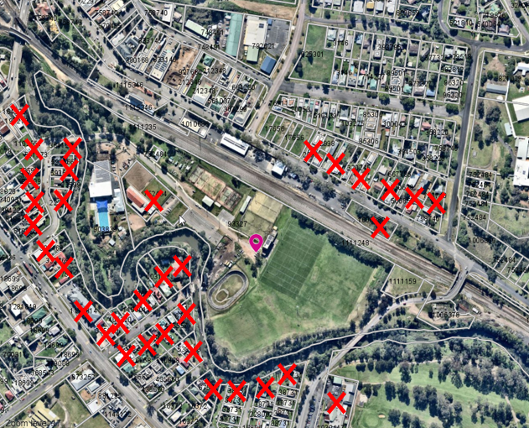

Image 6 – Letters to adjoining landowners

A total of one unique submission was received. And extract from the submission is provided below:

*The recent removal of the native vegetation at the end of Wilder Street for the construction of the bridge has exposed an eyesore of the current grandstand. There is an opportunity for its replacement, as proposed in this DA, to adopt an environmentally sympathetic façade, one that blends in with the local flora, much of which has been recently removed.*

The colour palette of the original plans submitted with the development application included bright blue and green colours.

In response to the submission, the Applicant lodged amended plans amending the colour of the façade to natural tones of light brown, grey and black.

The Olympic Park Master Plan also envisages the planting of new trees along the internal road network. When these mature they will provide screening to the new structure.

1. **CONCLUSION**

This development application has been considered in accordance with the requirements of the EP&A Act and the Regulations, Muswellbrook LEP 2009 and DCP 2009, and relevant State Environmental Planning Policies. Following an assessment of the relevant planning controls, documentation and technical studies submitted, issues raised in submissions, it is considered that the application can be supported subject to conditions.

**RECOMMENDATION**

That the Development Application DA No 2022-95 for demolition of an existing grandstand and the construction of a new Grandstand, Amenities and Function Centre at Olympic Park, 3 Wilkinson Ave Muswellbrook (Lot 7010 DP 93327), be approved pursuant to Section 4.16(1)(a) of the *Environmental Planning and Assessment Act 1979* subject to the recommended conditions of consent included as Attachment B to this report.